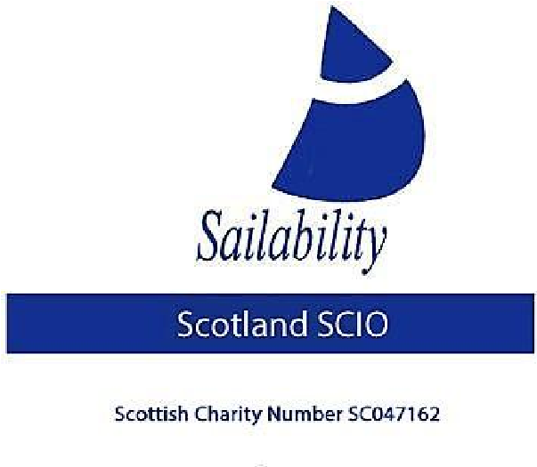
MEMBERSHIP APPLICATION
1 April 2025 to 31 March 2026

Name:
Address:
Post Code:
Contact
Telephone:
Email Address:
Type of  Membership |  Active (£15)   Weekend Regatta (£10)   Associates receive Information Only.
Signature:
Date:

Membership . . . . . £

Donation* . . . . . £

Total Paid . . . . . £ I have paid via PayPal

* Please see over
 I would like to receive information from the Challenger Class Association
 I accept the Privacy Statement

Sailability Scotland SCIO, Caledonia House,
1 Redheughs Rigg, Edinburgh EH12 9DQ Scottish Charity No. SC047162
Gift Aid declaration (for a single donation)
To
Sailability Scotland SCIO

Please treat the enclosed gift of £ . . . . . . . as a Gift Aid donation.

I confirm I have paid or will pay an amount of Income Tax and/or Capital Gains Tax for the current tax year (6 April to 5 April) that is at least equal to the amount of tax that all the Charities and Community Amateur Sports Clubs (CASCs) that I donate to will reclaim on my gifts for the current tax year. I understand that other taxes such as VAT and Council Tax do not qualify. I understand the Charity will reclaim 25p of tax on every £1 that I have given.

Donor’s details

Name:
Address:
Post Code:
Signature:
Date:

Please notify the Charity or CASC if you:

Want to cancel this declaration, change your name or home address, no longer pay sufficient tax on your income and/or capital gains.

If you pay Income Tax at the higher or additional rate and want to receive the additional tax relief due to you, you must include all your Gift Aid donations on your Self-Assessment tax return or ask HM Revenue and Customs to adjust your tax code.

Please return this form with payment (Cheques are payable to: Sailability Scotland) to:

Sailability Scotland SCIO c/o Stephen Laycock, Treasurer
Tongland Rd,
Kirkcudbright
DG6 4UU
treasurer@sailabilityscotland.org.uk

Sailability Scotland SCIO, Caledonia House
Scottish Charity No. SC047162

